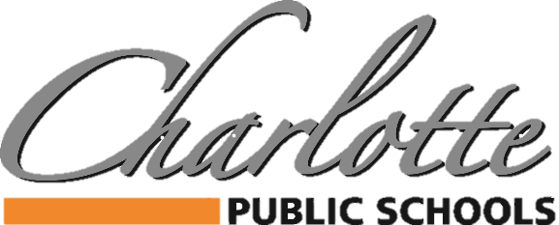

Our kids. Our community. Our future.
Capital Projects Bond 2020 Update
March 15, 2021

This is a very exciting time for Charlotte Public Schools and our staff, students and community. Your construction team has been hard at work since the passage of the bond proposal in November and we are excited to share with you an update on the Phase 1 projects. You will also find attached a projected timeline and some schematic designs to help you visualize some of the larger projects taking place in Phase 1. Please note that this is not an all inclusive list but highlights some of the larger projects taking shape.

Upper Elementary/Middle School Playground Equipment
- Student interest survey complete
- Initial conceptual design under way – target completion March 22nd
- Student/staff stakeholder group feedback on initial conceptual design – March/ Early April 2021
- Installation June/July 2021

Weymouth Playground Equipment
- Needs assessment complete
- Initial conceptual design under way – target completion March 22nd
- Student/staff stakeholder group feedback on initial conceptual design – March/Early April 2021
- Installation June/July 2021

High School Roof Replacement
- Bid document released and bids are due March 17th
- Bid recommendation presented to Board of Education on March 22nd
- Work completed June-August 2021

Parkview Playground Fencing
- Bidding April 2021
- Work completed June/July 2021

Washington Portables Removed
- Bidding May 2021
- Work completed by August 2021

Weymouth Secure Entry and Kitchen Remodel
- Stakeholder meetings complete and final construction documents approved
- Bid documents targeted for release on March 18th
- Bid recommendations to Board of Education on April 26th
- Work completed by end of August 2021

NEW Tennis Courts
- Stakeholder meetings complete and final construction documents approved
- Bid documents targeted for release on March 18th
- Bid recommendations to Board of Education on April 26th
- Work completed & relocation of practice football field by end of August 2021

NEW Concession Stand/Restroom Building
- Stakeholder meetings complete and final construction documents approved
- Bid documents targeted for release on March 18th
- Bid recommendations to Board of Education on April 26th
- Work completed by end of August 2021

NEW Agricultural Learning Center
- Stakeholder meetings are wrapping up with final drawings nearing completion.
- Bid documents will be released in April
- Construction will begin in July
- Work completed by the end of November 2021.

As we finalize the Phase 1 construction documents and begin the bidding process, we are also simultaneously starting to bring together stakeholder groups to discuss and plan for the Phase 2 projects. These projects include:
- Parkview Classroom & Media Center Furniture (Completed Summer 2022)
- Washington Classroom & Media Center Furniture (Completed Winter 2022)
- Washington Classroom Addition & Air Conditioning (Completed Winter 2022)
- Galewood Classroom & Media Center Furniture (Completed Winter 2022)
- Galewood Addition and Renovations, Including Air Conditioning (Completed Winter 2022)
- Charlotte High School Renovations, Including Air Conditioning (Completed Spring 2023)
- CHS Auxiliary Gym and Activity Room Addition (Completed Spring 2023)
- District Parking Lot Paving and Site Work (Completed August 2023)

We will begin planning for Phase 3 projects beginning in January 2022. These projects include:
- Parkview Air Conditioning (Completed August 2023)
- Upper Elementary/Middle School/Aquatic Center Improvements (Completed August 2023)
- Service Center Site Improvements (Completed August 2023)

Please visit our website regularly for updates and reminders associated with these important improvements. We hope you are as excited as we are to see this hard work become a reality thanks to the dedication of our team and the investment made by our community.
https://www.charlotteorioles.com/cpsbond2020/

Projected Construction Timeline
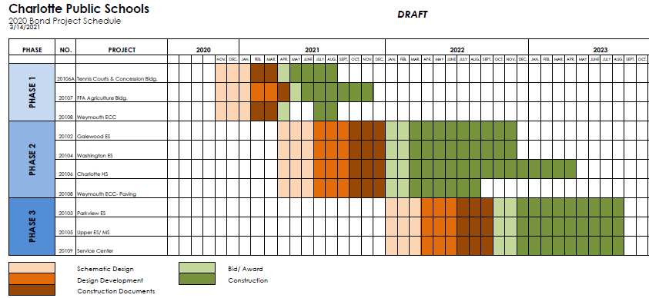

Weymouth Child Development Center – Kitchen Expansion, Classroom Access Relocation

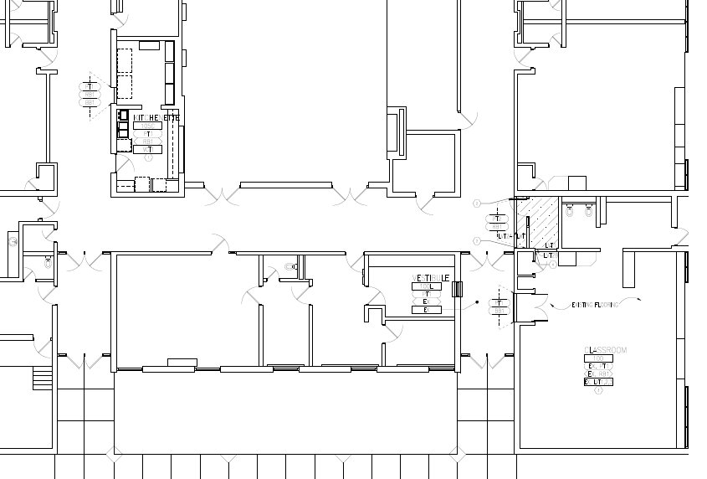

Tennis/Pickle Ball Courts & Concession/Restroom Building Site Plan
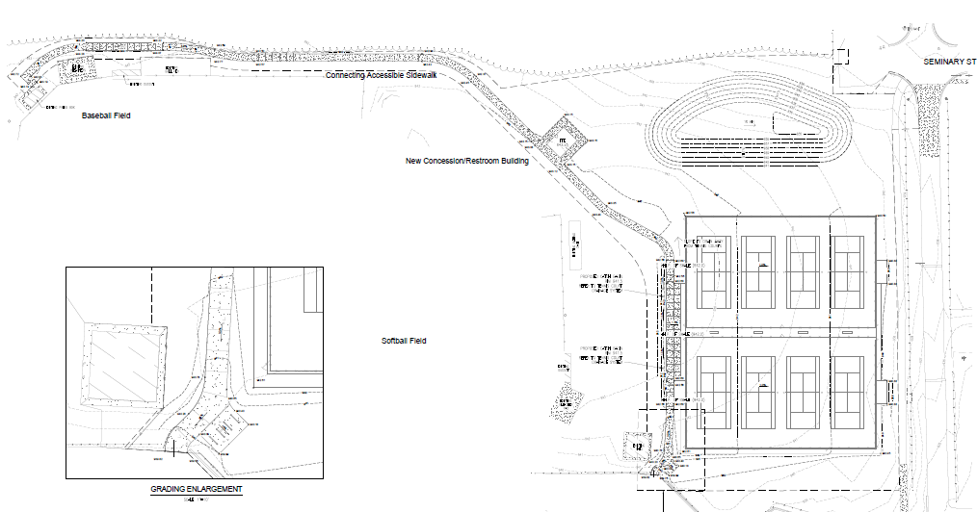

Agricultural Learning Center
