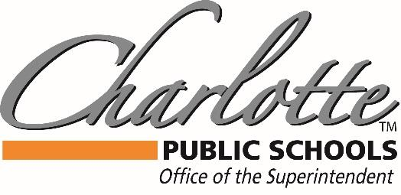

Dr. Mandy Stewart
378 State Street, Charlotte, MI 48813 PH: (517) 541-5100 FAX: (517) 541-5105
Safe Return to In Person Instruction and Continuity of Services

Health and Safety expectations

Cleaning:
We continue the surface cleaning in our schools, along with the use of our electrostatic sprayers
We encourage students to wash their hands, utilize hand sanitizer, and cover their mouths with any cough or sneeze
Our ionic air purifier attachments to our air handlers continue to be utilized

Distancing:
When possible, we continue to socially distance within the classroom, cafeteria, and in the hallways
We continue to encourage outdoor spaces for learning, and outdoor play

Cohorting/Screening
We continue with cohorting and seating charts, to minimize the amount of students that would be required to quarantine due to contact tracing
We encourage parents to screen their students daily for symptoms, and if they are ill, to keep them at home

Sports/extracurricular activities
We will follow the local Health department and MHSAA for any requirements made for activities.

Contact Tracing
We are still required by BEDHD/MDHHS to contact trace and report cases for quarantine. We will still communicate with families during this process
If you choose to vaccinate your student, and you share that proof with us, you will not be required to quarantine, per BEDHD current policy
We continue to track those students who have been positive within the 90 day window, as they also would not be required to quarantine. Please let us know if there has been a recent positive test for your student.

Masks:
With our current local data, we will not be requiring masks for students inside of the buildings; however, students can wear masks if they choose.
While we recommend wearing masks, this means masks will be optional for all staff, students, and visitors.

It is important to note, should we see increases in community transmission or there is an outbreak, we may need to review the mask requirement. For example, if there is a school outbreak or the local data becomes high, we would review the possibility of temporarily requiring masks, as an alternative to closing the building down or shifting to virtual programming. Please note that is plan is brought to the Board of Education at least every 6 months for any public comment or input open during Audience to Visitors section of the agenda.
Continuity of Services

Academic needs

As instructional needs have been affected by the pandemics, CPS will continue to offer intervention and supports for our students. Professional Development has been provided to staff, and frequent formative assessment data will be examined for any potential services through our MTSS (Multi- Tiered System of Supports) process. This may include WIN (What I Need) time, flexible groupings, tutoring, credit recovery, and/or Summer programming.

Social Emotional Needs

CPS has a full K-12 SEL curriculum for our students, to help with any social emotional needs. Also, we have Student Support Specialists in each building that support our staff and students specifically with mental health and behavior issues. We will continue to grow our staff wellness programming and SEL supports, as well as students’ supports in this area, in response to the pandemic.

Food Service

CPS will continue our free Breakfast and Lunch options K-12, while still offering Meet Up and Eat Up with our Summer Food Service Program, available for free to the community (adults and children). We also offer access to our Bird Feeder Food Pantry, which offers bags/boxes of food supplies and non-perishable food options for those who have need.

We are now enrolling for Fall 2022
Complete your enrollment today to take advantage of Summer 2022 programs!
Grow. Learn. Play. The Oriole Way. www.charlotteorioles.com

